Mathematics


Items highlighted in yellow are tasks for you to complete
Items in Blue italics are help tips

Multiply anything in your head

20 Multiply Up to 20X20 In Your Head

In just FIVE minutes you should learn to quickly multiply up to 20x20 in your head. With this trick, you will be able to multiply any two numbers from 11 to 19 in your head quickly, without the use of a calculator.
I will assume that you know your multiplication table reasonably well up to 10x10.
Try this:
- Take 15 x 13 for an example.
- Always place the larger number of the two on top in your mind.
- Then draw the shape of Africa mentally so it covers the 15 and the 3 from the 13 below. Those covered numbers are all you need.
- First add 15 + 3 = 18
- Add a zero behind it (multiply by 10) to get 180.
- Multiply the covered lower 3 x the single digit above it the "5" (3x5= 15)
- Add 180 + 15 = 195.
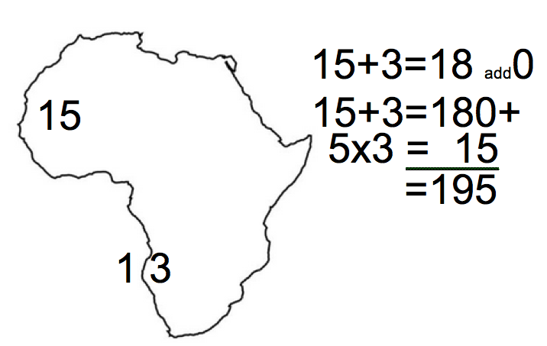

That is It! Wasn't that easy? Practice it on paper first!

